General
Ventilator Type | Natural Roof Ventilator
Base Dimensions | 580mm x 600mm
Dome Dimensions | 300mm w x 380mm d x 90mm h
Opening Diameter | 150mm or 200mm
Wind Loading | AS/NZS 4740 compliant
Bush Fire Rating | BAL-40

Material
Component | Material | Dimensions
Base | 0.6mm Aluminium | 580mm w x 600mm d
Dome | 1.0mm Steel | 300mm w x 380mm d x 90mm h
Seal | 2.0mm EPDM | 7mm w
200mm Neck | 0.8mm Galvanised steel | 200mm d x 93mm h
150mm Neck | 0.8mm Galvanised steel | 150mm d x 88mm h
200-150mm Adapter | 1.0mm Galvanised steel | 150/200mm d x 93mm h
150-125mm Adapter | 2mm ABS | 125/150mm d x 100mm h
Rivets | Aluminium | .3mm d
Strap | 1.0mm Aluminium | 210mm x 16mm

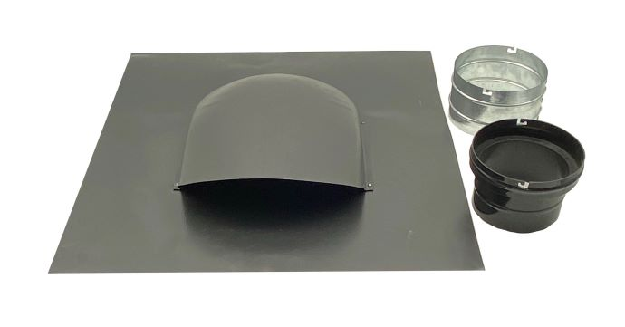
Weight
Component | Weight
Base | 1.45kg
200mm Neck | 210g
150mm Neck | 155g
200-150mm Reducer | 282g
150-125mm Reducer | 90g

Applicable Product Codes
Code | Description | Code | Description
RV56MM | 125-150mm Monument ® | RV68MM | 150-200mm Monument ®
RV56SG | 125-150mm Shale Grey TM | RV68SG | 150-200mm Shale Grey TM
RV56SM | 125-150mm Surfmist ® | RV68SM | 150-200mm Surfmist ®

Compliance with the National Construction Code
When installed correctly, roof vents can be used to assist with compliance under National Construction Code (NCC) provisions of 3.8.7

Compliance with AS3959
When installed correctly, low profile roof vents are compliant with the fire rating requirements of AS3959-2009 up to BAL-40

Conditions of Storage, Maintenance and Use
Keep stored in a dry and cool area in the original packaging
Do not attempt repair or maintenance without contacting Partner Pacific

Limitations of Use
Designed for Class 1 and Class 10 construction in non-cyclonic regions
Not to be used for gas flueing
Do not use for exhausting hazardous or explosive materials
Do not use if the pitch of the roof is less than 15 degrees

